MEDICAL DATA HISTORY
SQL Project Report
MySQL query solutions with supplied execution-result screenshots
Database: project_medical_data_history
34 tasks | Query script and result evidence

Project overview
This report organizes the 34 Medical Data History exercises into numbered sections. Each section includes SQL from the submitted script and the corresponding supplied result screenshot. Screenshots are presented as supplied evidence and have not been independently rerun against the database.
The script includes a one-time schema rename and an UPDATE statement. The project account previously returned MySQL Error 1142 for UPDATE, so Task 5 includes the read-only preview and its supplied screenshot. Task 34 joins through the original admissions column name.

Evidence notes
Task 32 contains an evidence mismatch: the SQL asks for weight groups, while screenshot 32 displays obesity-flag output, similar to screenshot 33. The report preserves the task query and labels the mismatch. Task 5 screenshot is a preview, not proof that stored data was updated.

Task 01
List male patients with first name, last name, and gender.
SELECT first_name, last_name, gender
FROM patients
WHERE gender = 'M';
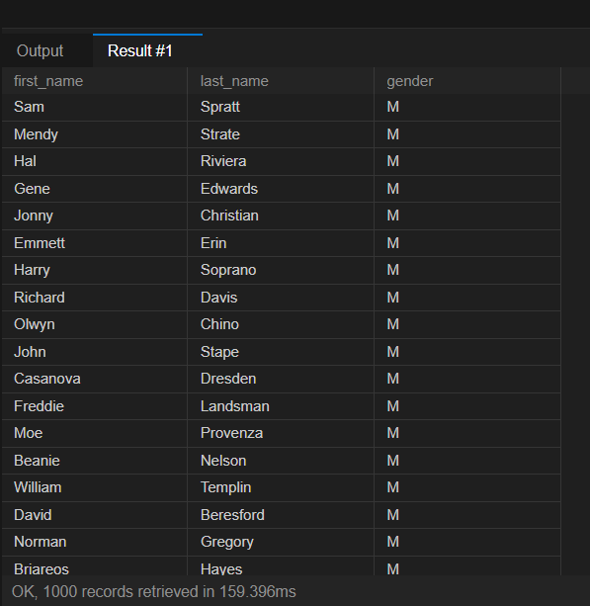
Figure 1. Supplied query result screenshot.

Task 02
List patients whose allergies are NULL.
SELECT first_name, last_name
FROM patients
WHERE allergies IS NULL;
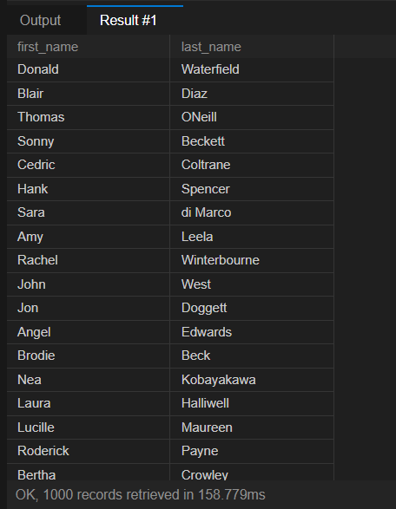
Figure 2. Supplied query result screenshot.

Task 03
List patients whose first name begins with C.
SELECT first_name
FROM patients
WHERE first_name LIKE 'C%';
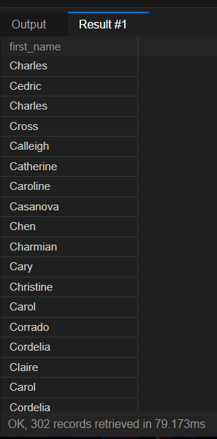
Figure 3. Supplied query result screenshot.

Task 04
List patients weighing between 100 and 120, inclusive.
SELECT first_name, last_name
FROM patients
WHERE weight BETWEEN 100 AND 120;
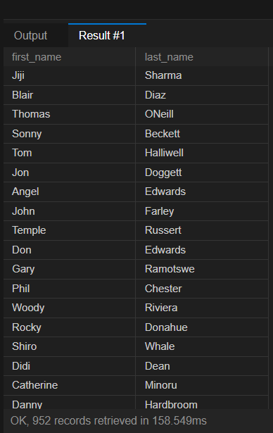
Figure 4. Supplied query result screenshot.

Task 05
Replace NULL allergies with NKA; preview the proposed values.
The supplied account was denied UPDATE permission (Error 1142); the preview below does not change stored data.
UPDATE patients
SET allergies = 'NKA'
WHERE allergies IS NULL;
SELECT
patient_id,
allergies AS original_allergies,
COALESCE(allergies, 'NKA') AS updated_allergies
FROM patients;
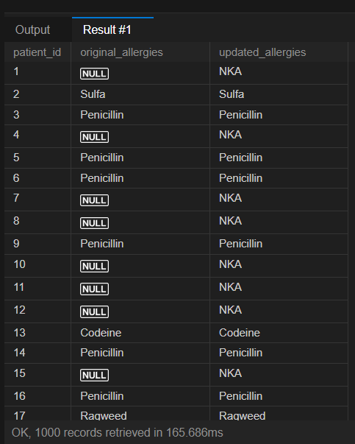
Figure 5. Supplied query result screenshot.

Task 06
Combine each patient first and last name into one full-name column.
SELECT CONCAT(first_name, ' ', last_name) AS full_name
FROM patients;
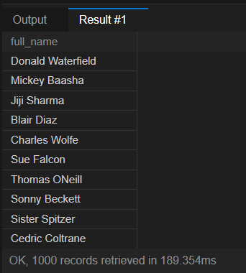
Figure 6. Supplied query result screenshot.

Task 07
Show patient names with their full province names.
SELECT p.first_name, p.last_name, pn.province_name
FROM patients AS p
JOIN province_names AS pn
ON p.province_id = pn.province_id;
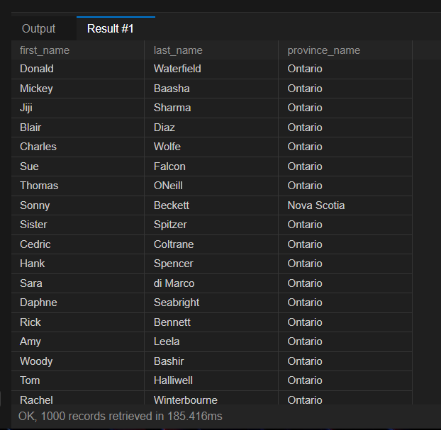
Figure 7. Supplied query result screenshot.

Task 08
Count patients born in 2010.
SELECT COUNT(*) AS patients_born_in_2010
FROM patients
WHERE YEAR(birth_date) = 2010;
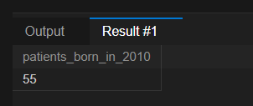
Figure 8. Supplied query result screenshot.

Task 09
Find the patient or patients with the greatest height.
SELECT first_name, last_name, height
FROM patients
WHERE height = (
SELECT MAX(height)
FROM patients
);
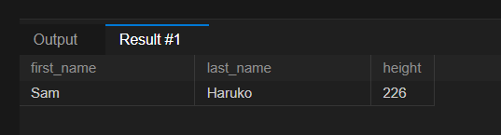
Figure 9. Supplied query result screenshot.

Task 10
Show all columns for patient IDs 1, 45, 534, 879, and 1000.
SELECT *
FROM patients
WHERE patient_id IN (1, 45, 534, 879, 1000);
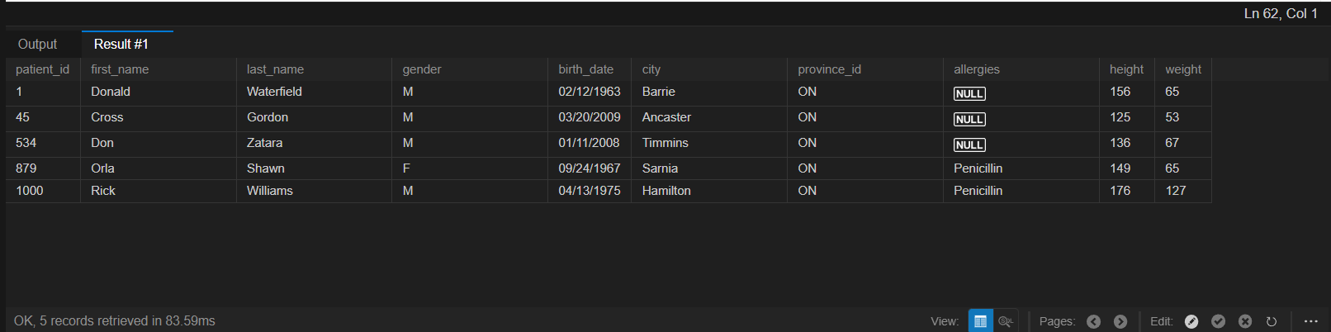
Figure 10. Supplied query result screenshot.

Task 11
Count all admissions.
SELECT COUNT(*) AS total_admissions
FROM admissions;

Figure 11. Supplied query result screenshot.

Task 12
Show admissions with matching admission and discharge dates.
SELECT *
FROM admissions
WHERE admission_date = discharge_date;
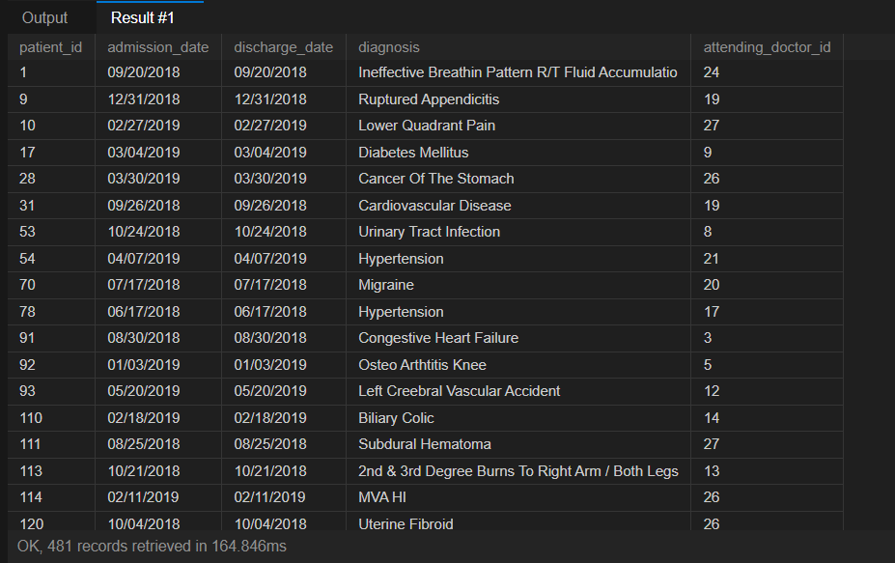
Figure 12. Supplied query result screenshot.

Task 13
Count admissions for patient 579.
SELECT COUNT(*) AS admissions_for_patient_579
FROM admissions
WHERE patient_id = 579;

Figure 13. Supplied query result screenshot.

Task 14
Show unique cities for patients in province NS.
SELECT DISTINCT city
FROM patients
WHERE province_id = 'NS';

Figure 14. Supplied query result screenshot.

Task 15
Find patients taller than 160 cm and heavier than 70 kg.
SELECT first_name, last_name, birth_date
FROM patients
WHERE height > 160
AND weight > 70;
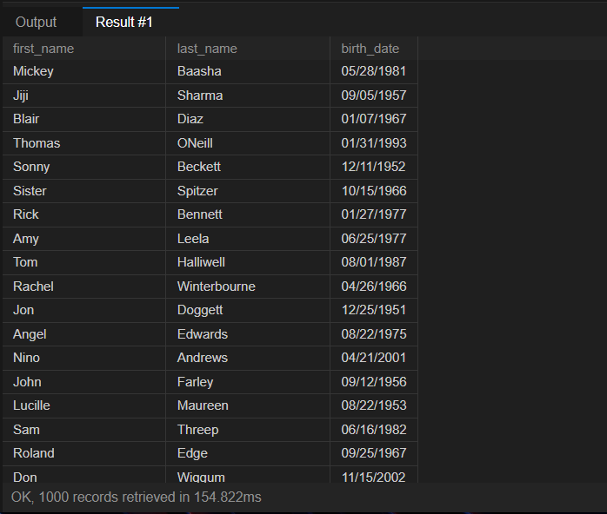
Figure 15. Supplied query result screenshot.

Task 16
List unique birth years in ascending order.
SELECT DISTINCT YEAR(birth_date) AS birth_year
FROM patients
ORDER BY birth_year;
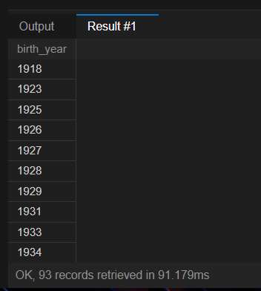
Figure 16. Supplied query result screenshot.

Task 17
List first names that occur exactly once.
SELECT first_name
FROM patients
GROUP BY first_name
HAVING COUNT(*) = 1;
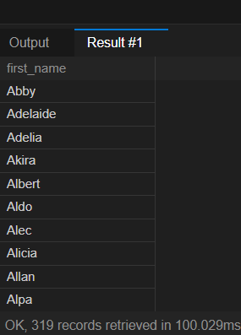
Figure 17. Supplied query result screenshot.

Task 18
Find first names beginning and ending with s and containing at least six characters.
SELECT patient_id, first_name
FROM patients
WHERE first_name LIKE 's%s'
AND LENGTH(first_name) >= 6;
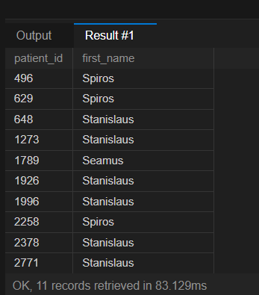
Figure 18. Supplied query result screenshot.

Task 19
List patients diagnosed with Dementia.
SELECT DISTINCT p.patient_id, p.first_name, p.last_name
FROM patients AS p
JOIN admissions AS a
ON p.patient_id = a.patient_id
WHERE a.diagnosis = 'Dementia';
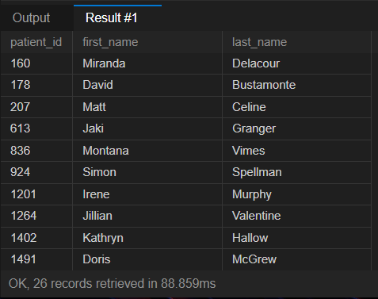
Figure 19. Supplied query result screenshot.

Task 20
Order patient first names by length, then alphabetically.
SELECT first_name
FROM patients
ORDER BY LENGTH(first_name), first_name;
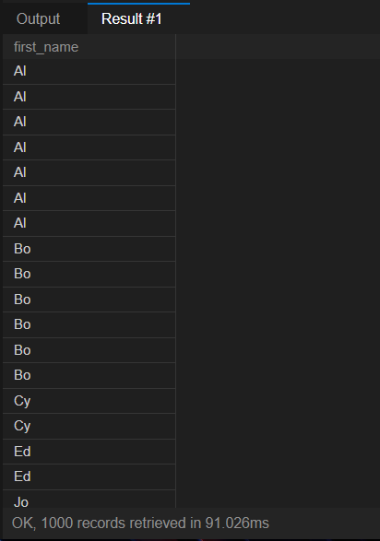
Figure 20. Supplied query result screenshot.

Task 21
Count male and female patients in the same row.
SELECT
SUM(gender = 'M') AS male_patients,
SUM(gender = 'F') AS female_patients
FROM patients;
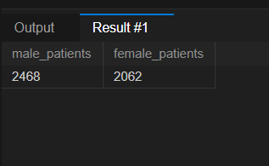
Figure 21. Supplied query result screenshot.

Task 22
Repeat the gender counts using conditional COUNT expressions.
SELECT
COUNT(CASE WHEN gender = 'M' THEN 1 END) AS male_patients,
COUNT(CASE WHEN gender = 'F' THEN 1 END) AS female_patients
FROM patients;
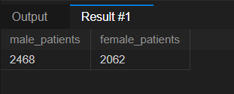
Figure 22. Supplied query result screenshot.

Task 23
Find patients admitted multiple times with the same diagnosis.
SELECT patient_id, diagnosis
FROM admissions
GROUP BY patient_id, diagnosis
HAVING COUNT(*) > 1;
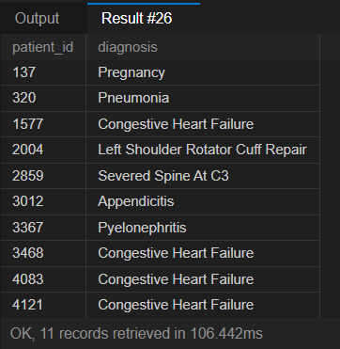
Figure 23. Supplied query result screenshot.

Task 24
Count patients by city, ordered by count descending and city ascending.
SELECT city, COUNT(*) AS patient_count
FROM patients
GROUP BY city
ORDER BY patient_count DESC, city ASC;
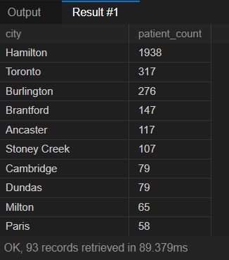
Figure 24. Supplied query result screenshot.

Task 25
List patients and doctors together with a role label.
SELECT first_name, last_name, 'Patient' AS role
FROM patients
UNION ALL
SELECT first_name, last_name, 'Doctor' AS role
FROM doctors;
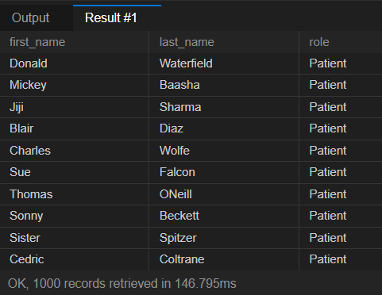
Figure 25. Supplied query result screenshot.

Task 26
Rank non-NULL allergies by patient count.
SELECT allergies, COUNT(*) AS total_patients
FROM patients
WHERE allergies IS NOT NULL
GROUP BY allergies
ORDER BY total_patients DESC;
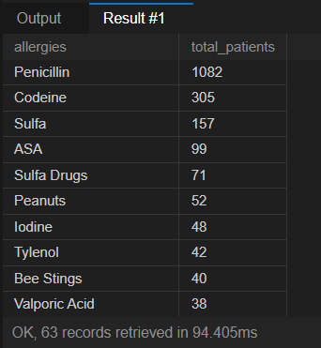
Figure 26. Supplied query result screenshot.

Task 27
List patients born in the 1970s, earliest birth date first.
SELECT first_name, last_name, birth_date
FROM patients
WHERE birth_date >= '1970-01-01'
AND birth_date < '1980-01-01'
ORDER BY birth_date ASC;
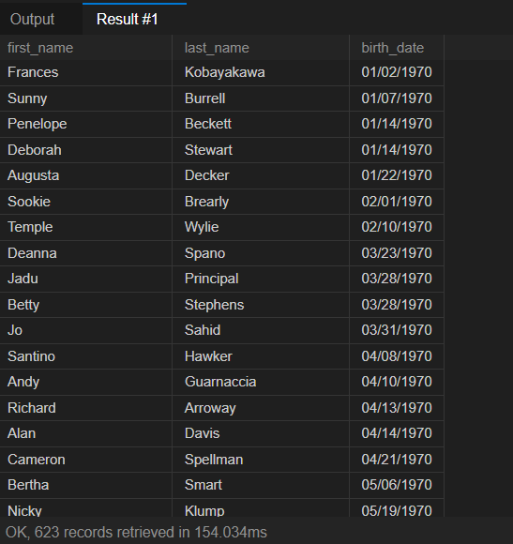
Figure 27. Supplied query result screenshot.

Task 28
Format last name uppercase and first name lowercase; sort by first name descending.
SELECT CONCAT(UPPER(last_name), ', ', LOWER(first_name)) AS full_name
FROM patients
ORDER BY first_name DESC;
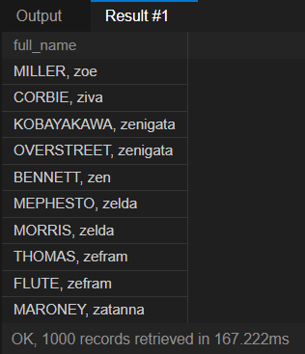
Figure 28. Supplied query result screenshot.

Task 29
Show provinces whose patient heights total at least 7,000.
SELECT province_id, SUM(height) AS total_height
FROM patients
GROUP BY province_id
HAVING SUM(height) >= 7000;
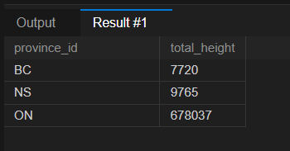
Figure 29. Supplied query result screenshot.

Task 30
Calculate weight range for patients with last name Maroni.
SELECT MAX(weight) - MIN(weight) AS weight_difference
FROM patients
WHERE last_name = 'Maroni';
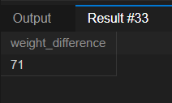
Figure 30. Supplied query result screenshot.

Task 31
Count admissions by day of month, ordered by busiest day.
SELECT
d.day_number,
COUNT(a.admission_date) AS admission_count
FROM (
SELECT ones.n + (tens.n * 10) + 1 AS day_number
FROM (
SELECT 0 AS n UNION ALL SELECT 1 UNION ALL SELECT 2 UNION ALL SELECT 3
UNION ALL SELECT 4 UNION ALL SELECT 5 UNION ALL SELECT 6 UNION ALL SELECT 7
UNION ALL SELECT 8 UNION ALL SELECT 9
) AS ones
CROSS JOIN (
SELECT 0 AS n UNION ALL SELECT 1 UNION ALL SELECT 2 UNION ALL SELECT 3
) AS tens
WHERE ones.n + (tens.n * 10) + 1 <= 31
) AS d
LEFT JOIN admissions AS a
ON DAY(a.admission_date) = d.day_number
GROUP BY d.day_number
ORDER BY admission_count DESC, d.day_number ASC;
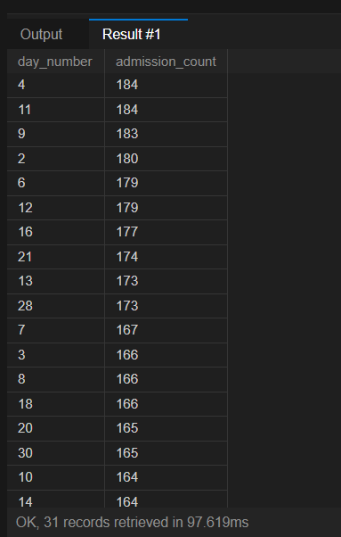
Figure 31. Supplied query result screenshot.

Task 32
Group patients into 10 kg weight bands and count each group.
SELECT
CONCAT(
FLOOR(weight / 10) * 10,
'-',
FLOOR(weight / 10) * 10 + 9
) AS weight_group,
COUNT(*) AS patient_count
FROM patients
GROUP BY FLOOR(weight / 10) * 10
ORDER BY FLOOR(weight / 10) * 10 DESC;
Evidence note: screenshot 32 shows an obesity-flag result, not the weight-band query above.
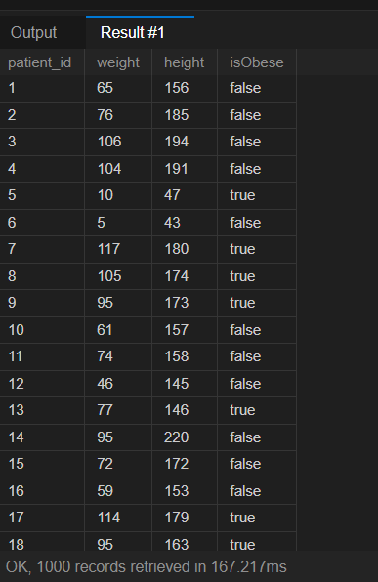
Figure 32. Supplied query result screenshot.

Task 33
Show patient weight, height, and obesity flag based on BMI >= 30.
SELECT
patient_id,
weight,
height,
CASE
WHEN weight / POWER(height / 100.0, 2) >= 30 THEN 1
ELSE 0
END AS isObese
FROM patients;
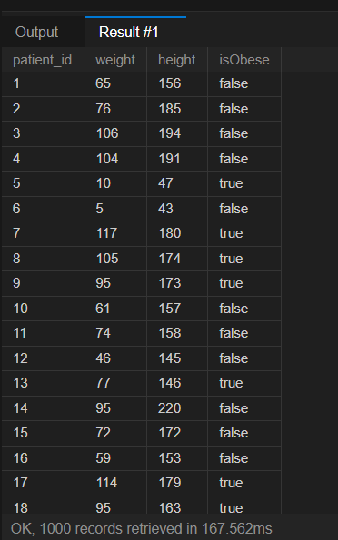
Figure 33. Supplied query result screenshot.

Task 34
Find Epilepsy patients whose attending doctor is Lisa and show doctor specialty.
SELECT
p.patient_id,
p.first_name,
p.last_name,
d.specialty
FROM patients AS p
JOIN admissions AS a
ON p.patient_id = a.patient_id
JOIN doctors AS d
ON a.attending_doctor_id = d.doctor_id
WHERE a.diagnosis = 'Epilepsy'
AND d.first_name = 'Lisa';
The join uses admissions.attending_doctor_id, the original column shown in the supplied schema.
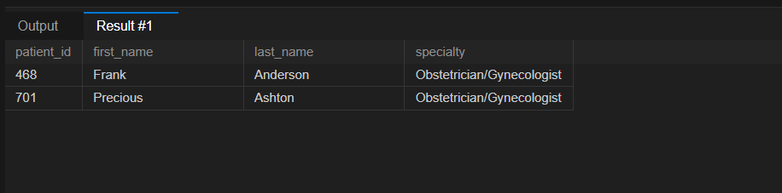
Figure 34. Supplied query result screenshot.

